Lab#05
Manipulation of type casting in Java
Objective
To get familiarity with the type casting in java.
Lab Goals
To provide working insight into the usage of type casting in java programming:
- Demonstrate the implementation of type casting.
- Explore implicit and explicit type casting in Java
Introduction to Java Type Casting
Type casting is when you assign a value of one primitive data type to another type. In Java, there are two types of casting:
• Widening Casting/ Implicit casting (automatically): Converting a smaller type to a larger type size.
byte -> short -> char -> int -> long -> float -> double
• Narrowing Casting/ Explicit casting (manually): Converting a larger type to a smaller size
type.
double -> float -> long -> int -> char -> short -> byte
Widening Casting/ Implicit casting
Widening casting is done automatically when passing a smaller size type to a larger size type:
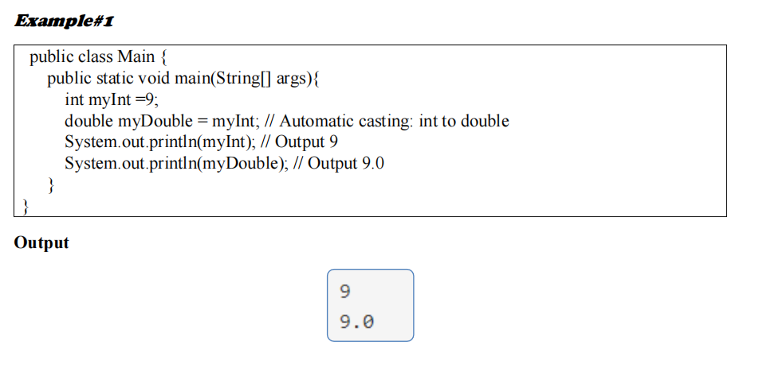

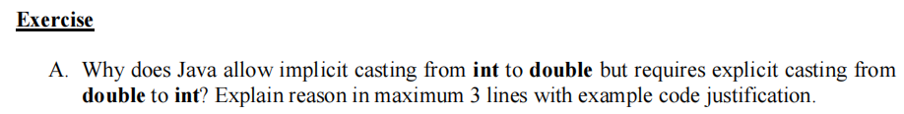
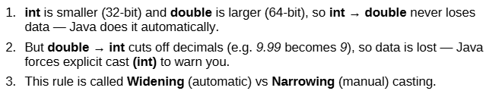
Example Code:
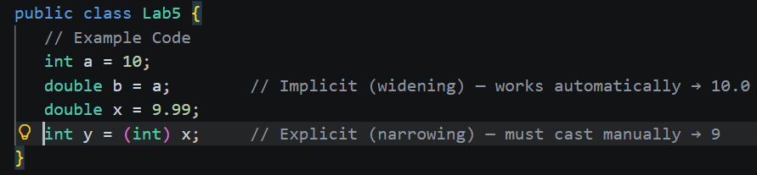
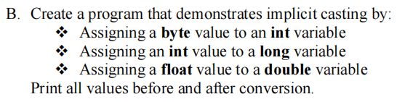
Program:
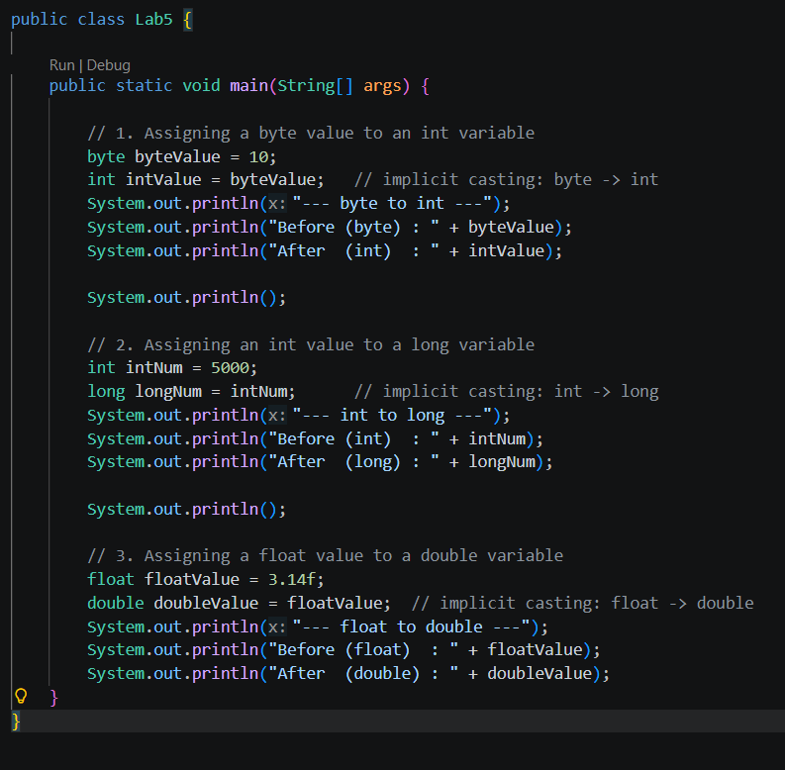
Output:
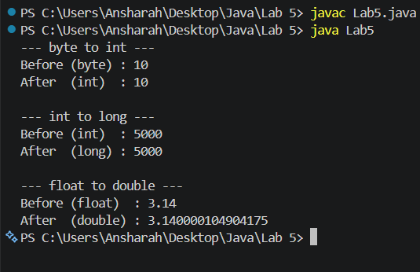
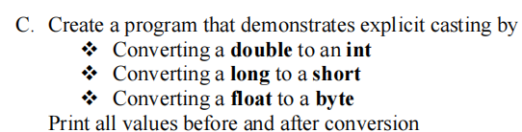
Program:
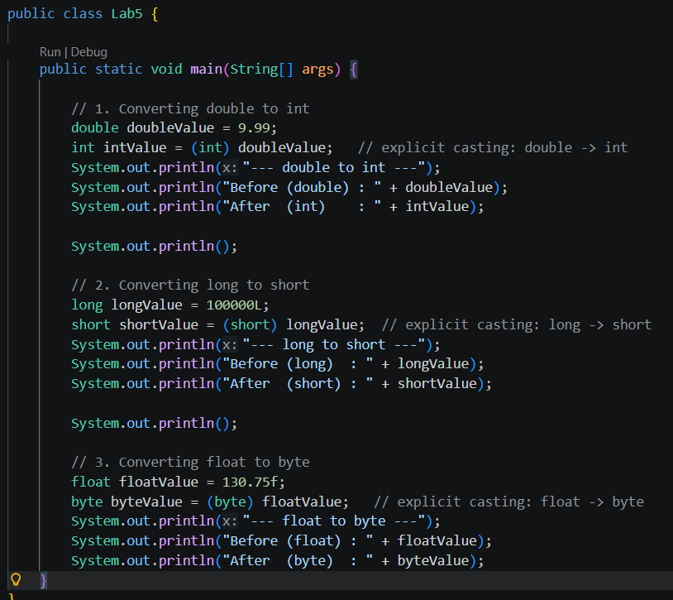
Output:
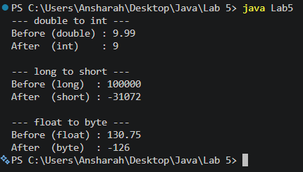
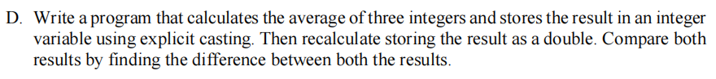
Program:
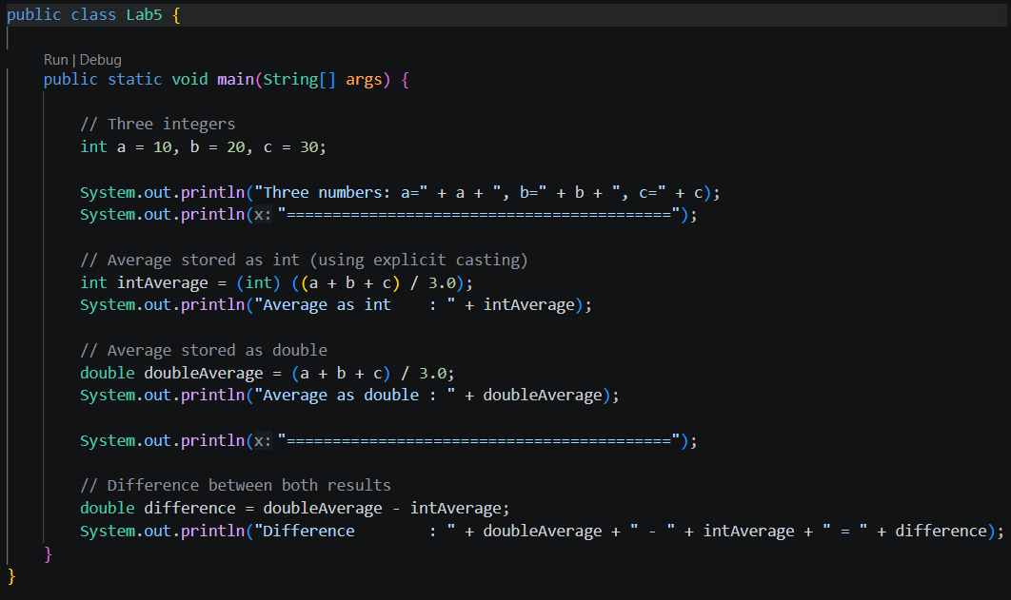
Output:
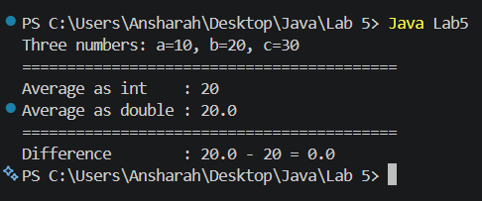

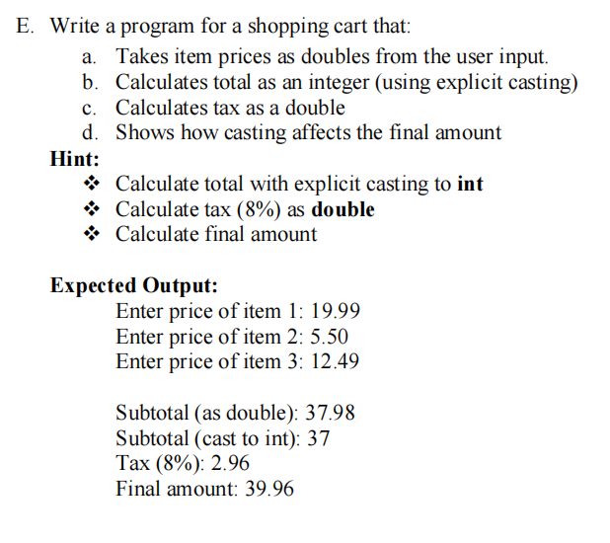
Program:
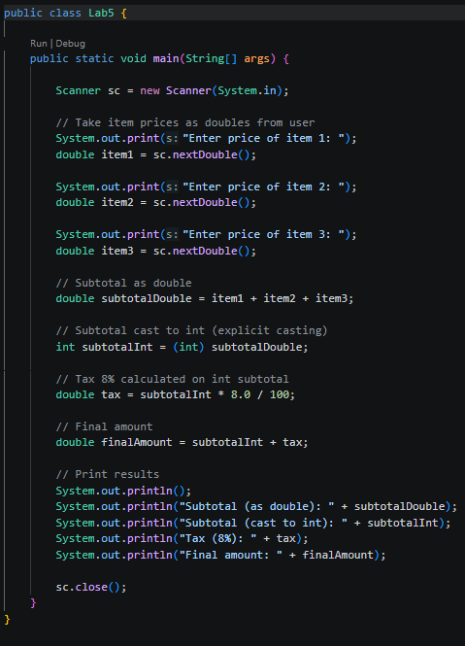
Output:
